5. MATLAB Code — Intelligent Wireless Data Filtering using Edge AI
This code classifies wireless data as Relevant, Irrelevant, or Uncertain based on an AI-style threshold and calculates the amount of data transmitted to the cloud.
Matlab code :-
clc; clear;
N = 100;
data = rand(1,N); % Wireless data
threshold = 0.6; % AI filtering threshold
filteredData = data(data >= threshold);
fprintf('Total Data : %d\n', N);
fprintf('Filtered Data : %d\n', length(filteredData));
fprintf('Data Reduction : %.2f%%\n', ...
(1-length(filteredData)/N)*100);
bar([N-length(filteredData), length(filteredData)]);
set(gca,'XTickLabel',{'Discarded','Transmitted'});
ylabel('Number of Samples');
title('Edge AI Data Filtering');
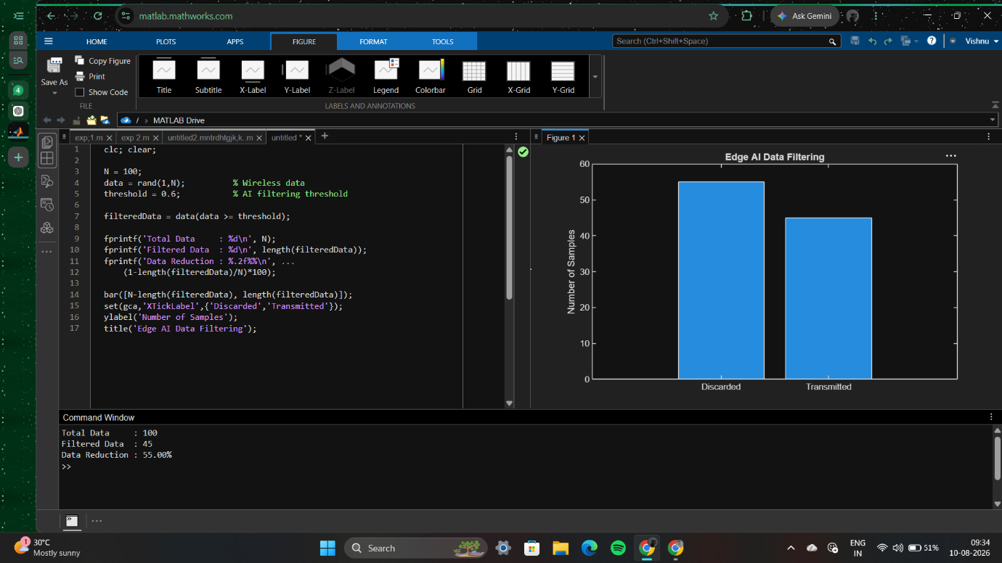

6. MATLAB Code — Edge–Cloud Task Offloading Strategy
This code compares local execution, edge execution, and cloud execution using latency, energy, and resource cost.
Matlab code :-
clc;
clear;
close all;
%% Edge-Cloud Task Offloading in 5G
N = 100; % Number of tasks
% Task characteristics
dataSize = randi([1 20],1,N); % Input data size (MB)
cpuCycles = randi([1 10],1,N); % Computational requirement
% Network parameters
edgeBandwidth = 100; % Mbps
cloudBandwidth = 50; % Mbps
% Processing speeds
deviceSpeed = 5; % CPU units
edgeSpeed = 20;
cloudSpeed = 50;
%% Calculate execution latency
% Local processing latency
localLatency = cpuCycles / deviceSpeed;
% Edge processing latency
edgeCommunication = (dataSize * 8) / edgeBandwidth;
edgeProcessing = cpuCycles / edgeSpeed;
edgeLatency = edgeCommunication + edgeProcessing;
% Cloud processing latency
cloudCommunication = (dataSize * 8) / cloudBandwidth;
cloudProcessing = cpuCycles / cloudSpeed;
cloudPropagation = 0.05; % 50 ms
cloudLatency = cloudCommunication + ...
cloudProcessing + cloudPropagation;
%% Energy consumption
localEnergy = localLatency * 2;
edgeEnergy = edgeCommunication * 1;
cloudEnergy = cloudCommunication * 1.2;
%% Cost function
alpha = 0.6; % Weight for latency
beta = 0.3; % Weight for energy
gamma = 0.1; % Weight for resource cost
localCost = alpha*localLatency + ...
beta*localEnergy + gamma*cpuCycles;
edgeCost = alpha*edgeLatency + ...
beta*edgeEnergy + gamma*(cpuCycles/edgeSpeed);
cloudCost = alpha*cloudLatency + ...
beta*cloudEnergy + gamma*(cpuCycles/cloudSpeed);
%% Offloading decision
decision = zeros(1,N);
% 1 = Local
% 2 = Edge
% 3 = Cloud
for i = 1:N
costs = [localCost(i), edgeCost(i), cloudCost(i)];
[~, decision(i)] = min(costs);
end

%% Display results

localTasks = sum(decision == 1);
edgeTasks = sum(decision == 2);
cloudTasks = sum(decision == 3);

fprintf('Total number of tasks = %d\n',N);
fprintf('Tasks executed locally = %d\n',localTasks);
fprintf('Tasks offloaded to edge = %d\n',edgeTasks);
fprintf('Tasks offloaded to cloud = %d\n',cloudTasks);
%% Plot task distribution
figure;
bar([localTasks edgeTasks cloudTasks]);
set(gca,'XTickLabel',{'Local','Edge','Cloud'});
ylabel('Number of Tasks');
title('5G Task Offloading Strategy');
grid on;
%% Plot latency comparison
figure;
plot(1:N,localLatency,'b','LineWidth',1.5);
hold on;
plot(1:N,edgeLatency,'r','LineWidth',1.5);
plot(1:N,cloudLatency,'g','LineWidth',1.5);
xlabel('Task Number');
ylabel('Latency');
title('Latency Comparison');
legend('Local','Edge','Cloud');
grid on;
